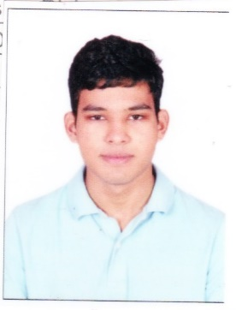**7th Project Innovation Contest-2018**

**(A sister concern activity of 14th ICDCIT 2018)**

**Registration Form**

1. Name of the Team Lead: Adeeb Tahir R

**(Student Participant)**

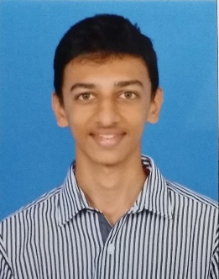2. Mobile No.: 7299003427

3. Email ID: adeeb.tr@gmail.com

4. Project ID: 46

5. Title of Project: Quick Basket

6. Institute/University Details: SSN College Of Engineering, Kalavakkam

7. Name of Faculty Mentor: Mrs. S Sasirekha

8. Name of other team members:

(1) Adithya R Ganesh

9. Travel Schedule: Date of Arrival: 10.01.2018, Time: 4 P.M

Date of Departure: 14.01.2018, Time: 11 A.M



10. Accommodation required in Hostel (kindly tick): Yes/No

(Note: Hostel accommodation is free for PIC participants)

11. Bank details for reimbursement of Travel Allowance (any one student participant):

**(i) Account Holder's Name :** Adeeb Tahir Rahamathullah

**(ii) SB Account No. :** 20243684358

**(iii) Bank Name & Address :** State Bank Of India, PADUR SNO. 637/2,

OMR ROAD

**(iv) Bank IFSC code :** SBIN0017181

**Note:** Travel Allowance will provided only to outstation participants after submission of hard copy of their tickets (only sleeper class ticket with shortest route is admissible) along with TA form. (TA form will be provided during the event).

The registration form should be attached with the following documents:

1. Scanned copy of No Objection Certificate from the Head of the Institute/Department and hard copy of the same to be submitted on arrival.
2. Soft copy of the Complete Project Report.
3. Video demonstration of the Project (Two Minutes approx.).